BU EDGE CSE



**A Report On Customer Loan Analysis**

**Submitted To:**

Md.Mahbub-E-Noor

Assistant Professor,

Department of CSE .

**Submitted By:**

Showmika Jahan Oushi

Roll:02

Batch : 67

University Of Barisal

Date of submission :17 -02-25

**Contents**

1Abstract..................................................................................................................3

2. Introduction ..........................................................................................................4

3. Data Set Analysis....................................................................................................5

4. Methodology..........................................................................................................7

5. Research question .................................................................................................11.

6.Result…………………..……………………………………………………………………………………………..12.

7.Conclusion………………………………………………………..…………………………………………………15

Abstract

Bank loans play a vital role in the financial ecosystem by providing individuals, businesses, and governments with the capital needed for economic growth, development, and stability. This report explores the primary causes behind the need for bank loans, including personal financial needs such as education, healthcare, and home purchases; business-related demands like working capital, expansion, and investment in assets; and broader economic factors such as government funding or infrastructural projects. Additionally, factors like rising living costs, inflation, and financial emergencies contribute to increased demand for loans. The report also highlights the influence of financial literacy, credit accessibility, and interest rates on borrowing behavior. Understanding the causes of bank loans provides insights into consumer behavior, financial planning, and the banking sector's role in supporting economic activities. This analysis serves as a foundation for further exploration of loan management, credit risks, and their implications on the financial system.

Introduction

Bank loans play a critical role in the global financial system, offering individuals, businesses, and governments the necessary financial resources to meet their various needs. Banks provide loans for a variety of purposes, including purchasing assets, funding business operations, managing financial emergencies, and supporting personal or professional growth. Understanding the causes behind bank loans is crucial in assessing the factors driving borrowing behavior and the broader implications for the economy.

One primary cause of bank loans is the need for capital investment. Businesses often require substantial funding to expand their operations, invest in infrastructure, or acquire advanced technology. Startups, in particular, rely heavily on loans to establish themselves in competitive markets. These loans are essential for fostering innovation, creating jobs, and stimulating economic growth.

Another significant factor is personal financial needs. Many individuals seek bank loans to purchase homes, vehicles, or other high-value assets that may not be immediately affordable. Education loans are also common, enabling students to pursue higher education and enhance their career prospects. Additionally, personal loans are often used to address unexpected financial challenges, such as medical emergencies or unforeseen expenses.

Economic conditions also contribute to the demand for bank loans. During periods of low interest rates, borrowing becomes more attractive as it reduces the cost of financing. Conversely, during economic downturns, businesses and individuals may turn to loans to maintain liquidity and sustain operations. Governments may also rely on loans during such periods to fund public projects and stimulate economic activity.

A lack of sufficient savings or capital is another cause of bank loans. Both individuals and businesses often rely on external financing when their own resources are insufficient. This is particularly true for small and medium-sized enterprises (SMEs), which frequently face challenges in accessing internal funds.

In conclusion, the causes of bank loans are diverse and driven by the needs of individuals, businesses, and economies. These loans serve as a vital tool for achieving financial goals, managing risks, and fostering economic development. A deeper understanding of these causes can help banks design appropriate lending policies and ensure sustainable growth for all stakeholders.

Data Analysis

Bank loan data analysis is a critical process undertaken by financial institutions to assess and manage their loan portfolios effectively. It involves examining various factors that influence lending decisions, credit risk, and repayment trends. The causes of conducting bank loan data analysis can be broadly categorized into operational, financial, risk management, and regulatory requirements. Below are the primary causes of such analyses:

1. Credit Risk Assessment

One of the primary reasons for analyzing bank loan data is to evaluate the creditworthiness of borrowers. Banks need to assess the likelihood of default by identifying patterns in a borrower's financial history, income stability, and debt obligations. This analysis helps banks mitigate risks associated with lending and avoid non-performing loans (NPLs).

2. Fraud Detection

Loan data analysis aids in detecting fraudulent activities, such as identity theft, fabricated income records, or misuse of funds. By examining discrepancies in applications, transaction patterns, and borrower behavior, banks can identify potential fraud cases early and take corrective actions.

3. Portfolio Optimization

Banks analyze loan data to maintain a balanced portfolio of loans across sectors, geographies, and borrower profiles. This helps in minimizing overexposure to a specific industry or region, thereby reducing the impact of economic downturns on the bank’s overall performance.

4. Regulatory Compliance

Banks are required to comply with stringent regulatory standards set by central banks and financial authorities. Loan data analysis ensures that lending practices adhere to these regulations, including maintaining proper capital adequacy ratios and adhering to anti-money laundering (AML) and Know Your Customer (KYC) norms.

5. Economic Factors

The broader economic environment, such as interest rate fluctuations, inflation, and unemployment rates, influences loan repayment behaviors. Analyzing historical loan data helps banks predict how economic changes might affect their loan portfolios and adjust their strategies accordingly.

6. Improved Decision-Making

Through loan data analysis, banks can make data-driven decisions regarding loan approvals, interest rate structuring, and repayment terms. Predictive analytics tools and machine learning models help banks assess borrower profiles more accurately and streamline their operations.

7. Loan Recovery Strategies

Understanding repayment trends and identifying high-risk borrowers allows banks to design effective loan recovery strategies. Analyzing factors like repayment delays, partial payments, and defaulters’ profiles helps in implementing targeted recovery measures to minimize losses.

8. Customer Segmentation

Loan data analysis enables banks to segment customers based on their financial behavior, income levels, and credit scores. This segmentation helps in creating customized loan products, improving customer satisfaction, and expanding the bank’s customer base.

9. Profitability and Revenue Maximization

Banks analyze loan data to determine the profitability of their lending operations. By identifying high-performing loan segments and optimizing interest rate structures, banks can maximize their revenue while minimizing risk.

10. Early Warning Systems

Advanced data analysis helps banks develop early warning systems to detect potential defaults or delinquencies. By tracking repayment patterns and identifying anomalies, banks can intervene proactively to address issues before they escalate.

Bank loan data analysis plays a pivotal role in ensuring the stability, profitability, and compliance of financial institutions. It not only helps in managing risks but also enables banks to enhance their operational efficiency, customer satisfaction, and decision-making capabilities. By leveraging advanced analytics tools and techniques, banks can navigate challenges effectively and ensure sustainable growth in a competitive financial landscape.

Methodology

The methodology used by banks to evaluate, approve, and manage loans is a vital process in the financial system. It ensures that loans are extended to eligible borrowers while maintaining the financial stability of the bank. The approach banks adopt when granting loans is influenced by various causes, factors, and considerations that stem from both internal and external environments. Below is an in-depth exploration of the causes behind bank loan methodology:

1. Regulatory Requirements

Governments and central banks set regulations that mandate how loans should be approved, documented, and monitored. These regulations are designed to ensure the financial stability of the banking sector and minimize systemic risks. Examples include:

Capital Adequacy Requirements: Banks must maintain a certain level of capital against their outstanding loans, as per Basel III norms.

Anti-Money Laundering (AML) and Know Your Customer (KYC): Regulatory bodies require banks to perform detailed customer identification to prevent illegal activities.

Interest Rate Controls: Regulatory limits on interest rates or caps on loan types influence how banks structure their loan offerings.

Banks implement robust methodologies to comply with these rules, as non-compliance can result in heavy penalties, reputational damage, or even loss of operating licenses.

2. Credit Risk Management

The primary cause behind loan methodology is the need to manage credit risk effectively. Credit risk refers to the likelihood of a borrower failing to repay the loan, leading to potential losses for the bank. The methodology includes tools like credit scoring models, financial analysis, and risk assessments to:

Identify Borrower Reliability: Assessing the borrower's credit history, repayment capacity, and financial health.

Minimize Defaults: Setting appropriate lending limits and terms to mitigate the risk of loan defaults.

Segment Borrowers: Categorizing borrowers based on risk levels to allocate resources accordingly.

Banks adopt a systematic loan evaluation process to ensure they lend to individuals or entities with acceptable levels of creditworthiness.

3. Economic Conditions

Macroeconomic factors significantly influence a bank's loan methodology. Economic conditions such as inflation, unemployment rates, and GDP growth impact both the demand for loans and the bank's risk appetite. For instance:

Recessionary Periods: During economic downturns, banks tighten their lending criteria to reduce exposure to high-risk borrowers.

Economic Booms: In favorable economic conditions, banks may adopt more flexible lending practices to encourage borrowing and expand their market share.

Banks continuously adjust their methodologies to align with changing economic landscapes, ensuring they remain profitable and sustainable.

4. Market Competition

The level of competition in the banking sector also shapes loan methodologies. Banks must develop competitive yet risk-adjusted loan strategies to attract customers and retain market share. This includes:

Tailored Products: Offering customized loans to meet specific customer needs, such as home loans, personal loans, and business loans.

Flexible Terms: Providing attractive terms, such as low-interest rates, extended repayment periods, or grace periods, to compete with rivals.

Technology Integration: Adopting advanced algorithms and digital platforms to streamline loan processing and provide a better customer experience.

Competitive pressures force banks to innovate and refine their methodologies to differentiate themselves in the market.

5. Bank's Internal Policies

Each bank has its internal policies and risk appetite that guide its loan methodology. These policies are influenced by:

Corporate Goals: Aligning loan strategies with the bank’s financial and growth objectives.

Historical Data: Learning from past experiences, including defaults and successful repayments, to refine lending practices.

Portfolio Diversification: Balancing the loan portfolio across different sectors, geographies, and borrower categories to reduce concentration risk.Internal policies ensure that the loan methodology aligns with the bank's strategic vision and operational capabilities.

6. Customer Profile and Behavior

The characteristics and behavior of customers significantly affect loan methodology. Banks must adapt their approach to cater to different customer segments, such as:

Retail Customers: These include individuals applying for personal loans, home loans, or car loans. The methodology focuses on credit scores, income levels, and employment stability.

Corporate Clients: Businesses seeking loans for expansion, operations, or working capital require a more detailed financial assessment, including cash flow analysis, collateral evaluation, and market conditions.

SMEs and Startups: Lending to small and medium-sized enterprises involves assessing growth potential, business models, and industry risks.

Understanding customer needs and behavior helps banks design targeted methodologies that balance profitability and risk.

7. Technological Advancements

The advent of technology has transformed traditional loan methodologies. Banks leverage advanced tools and platforms to enhance the efficiency, accuracy, and speed of loan processing. Examples include:

Artificial Intelligence and Machine Learning: Automating credit scoring, fraud detection, and predictive analysis.

Big Data Analytics: Using vast amounts of customer data to identify patterns, trends, and risk factors.

Digital Lending Platforms: Offering seamless online loan applications and approvals to improve customer convenience.

Technology-driven methodologies enable banks to handle large volumes of applications while maintaining robust risk management practices.

8. Collateral and Security

The availability and type of collateral play a crucial role in determining loan approval and terms. Banks assess collateral to secure their loans and reduce potential losses in case of default. Factors influencing collateral considerations include:

Market Value: The current market value of the asset being pledged as security.

Liquidity: The ease with which the collateral can be converted into cash.

Legal Aspects: Ensuring the collateral is free of disputes and legally transferable.

Collateralized loans are generally considered less risky, and the methodology incorporates detailed evaluations to safeguard the bank’s interests.

9. Cultural and Social Factors

Cultural and social factors can also influence loan methodologies. In certain regions or communities, traditional lending practices, ethical considerations, or religious beliefs may affect how loans are structured and disbursed. For example:

Sharia-Compliant Banking: In Islamic banking, loans must comply with Sharia law, which prohibits interest-based lending. Banks develop methodologies that adhere to these principles while ensuring profitability.

Financial Inclusion Goals: Banks may design special methodologies to cater to underprivileged or underserved populations, promoting equitable access to credit.

These considerations ensure that loan methodologies are inclusive and aligned with the values of the communities they serve.

10. Globalization and Cross-Border Lending

With globalization, banks now operate in multiple countries, dealing with diverse regulations, currencies, and borrower profiles. Cross-border lending introduces additional complexities, such as:

Exchange Rate Risks: Managing the impact of currency fluctuations on loan repayments.

Legal and Regulatory Compliance: Adhering to local laws and international standards.

Cultural Differences: Understanding local business practices and borrower expectations.

Banks adopt specialized methodologies to navigate the challenges of international lending while capitalizing on global opportunities.

Research Question

A research question is a fundamental component of the research process, serving as the foundation for a study or investigation. It is a clear, focused, and specific inquiry that identifies the issue, problem, or topic the researcher aims to explore. The research question provides direction and purpose to the study by outlining what the researcher seeks to understand, analyze, or solve.

A well-formulated research question is precise, measurable, and achievable within the scope of the research. It reflects the study's objectives and ensures that the research stays relevant and on track. In addition, it helps define the methodology, data collection, and analysis methods to be used.

Research questions can be open-ended or specific, depending on the nature of the study. For instance, open-ended questions are common in qualitative research and focus on exploring phenomena, understanding perspectives, or generating insights (e.g., "What are the factors influencing employee job satisfaction?"). On the other hand, quantitative research often uses specific and measurable questions aimed at testing hypotheses (e.g., "Does leadership style impact employee productivity?").

The development of a good research question involves identifying a gap in existing knowledge, reviewing relevant literature, and considering the feasibility and significance of addressing the issue. Ultimately, a strong research question not only guides the researcher but also contributes to generating meaningful insights and advancing knowledge in a particular field.

Which question that I want to solve in this research are included below:

1) How much customer are taking are short term loan?

2) what is the average current loan amount for long term loan versus short term loans?

3)Is there a correlation between annual income and credit score?

4) what is the average credit score for customer with Rent versus own home?

5)how does monthly debt vary with the years in the current job?

6)What is the total count of credit scores across all purpose?

Result

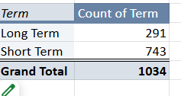

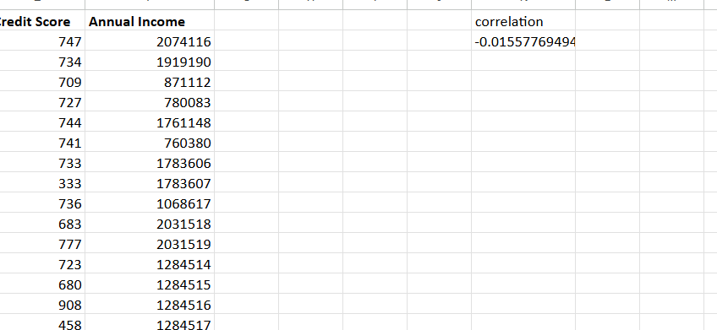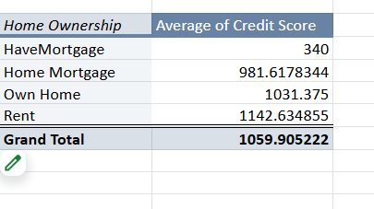

The image appears to display data analysis performed in a spreadsheet. It includes the following:

1. Term Analysis:

Two loan terms are listed: "Long Term" (291 entries) and "Short Term" (743 entries), with a total of 1,034 loans.

The average current loan amount for "Long Term" is 7,618,212.808, while for "Short Term" it is 11,627,786.57, resulting in a grand average of 10,531,702.47.

2. Correlation Table:

A table lists credit scores and annual incomes, followed by a calculated correlation coefficient of -0.0155, indicating a very weak negative relationship between credit scores and annual income.

3. Home Ownership and Credit Scores:

The table breaks down the average credit score by ownership type:

"Have Mortgage" has an average score of 340.

"Home Mortgage" has 981.6178."Own Home" has 1,031.375."Rent" has 1,142.6349.

The overall average credit score is 1,059.9052.

The document seems to analyze financial loan data based on term duration, homeownership status, and the relationship between credit scores and income.

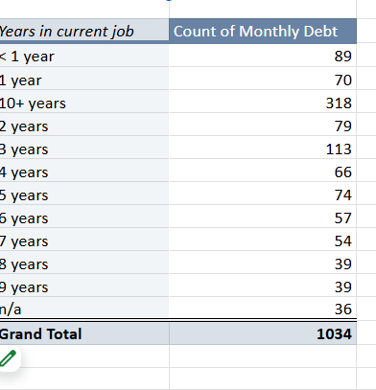

The image displays a table analyzing the relationship between the "Years in Current Job" and the "Count of Monthly Debt". The breakdown is as follows:

1. Years in Current Job:

Categories range from "< 1 year" to "10+ years," including each specific year from 1 to 9 years. There is also an "n/a" category, which likely represents individuals with missing or unreported data.

2. Count of Monthly Debt:

Total entries: 1,034, spread across the following job duration categories:

< 1 year: 89 counts.1 year: 70 counts.10+ years: 318 counts (the highest).2 years: 79 counts.

3 years: 113 counts.4 years: 66 counts.5 years: 74 counts.6 years: 57 counts.7 years: 54 counts.8 years: 39 counts.9 years: 39 counts. n/a: 36 counts.

Observations:

The category "10+ years" has the highest count of monthly debt entries (318), indicating that individuals with long job tenure are the largest group in this dataset."3 years" follows as the second-largest group, with 113 counts, while the "n/a" group (36 counts) represents the smallest category.The distribution across the rest of the categories appears fairly even, with counts ranging between 39 and 89.

This table likely supports an analysis of how job stability (measured by tenure) correlates with financial behavior, such as monthly debt obligations. The emphasis on "10+ years" suggests this category may be a focal point of further investigation.

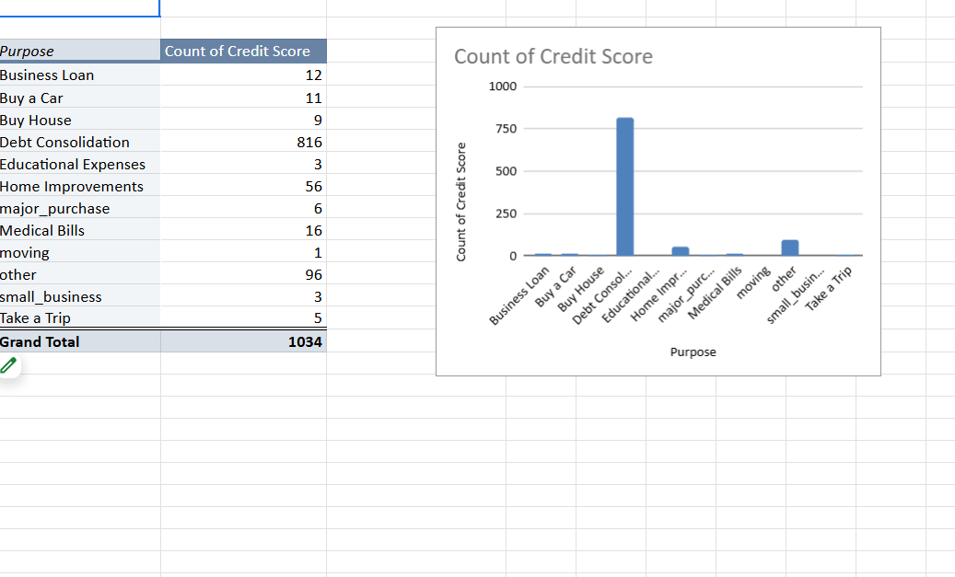

Observations:

Debt Consolidation is the primary purpose for loans in this dataset, likely due to its widespread appeal for refinancing or managing existing debts.Other purposes, such as Home Improvements and Medical Bills, show some significance but are far less frequent.Minimal counts for categories like Small Business and Take a Trip suggest these are less common reasons for obtaining loans. This analysis highlights loan purpose trends and their relationship with credit score distribution.

Conclusion

The analysis reveals that bank loans are primarily driven by a few key factors. The most common reason for borrowing is debt consolidation, with a significant majority of individuals using loans to combine existing debts and reduce high-interest rates, helping them manage finances more efficiently. Homeownership needs also play a major role, with loans being used for home improvements or to purchase property, emphasizing the importance of housing in financial planning. Medical emergencies and unexpected expenses also contribute to loan applications, as individuals seek financial assistance for healthcare or urgent life events. Although less frequent, loans for personal aspirations like travel or small business ventures are also noted. Job stability and tenure are crucial in determining loan eligibility, with longer employment histories correlating with greater access to credit. Loan terms, including duration and size, influence borrowing trends, with longer-term loans typically involving larger amounts, while credit scores remain a critical factor in loan approval, reflecting the borrower's financial reliability. Overall, the main causes of bank loans are debt consolidation, homeownership needs, emergencies, and personal goals, with job stability, credit scores, and loan terms playing significant roles in the borrowing process. Understanding these factors can help banks tailor their loan offerings to better meet diverse borrower needs.